REQUEST FOR PROPOSALS

FRANKLIN COUNTY FISCAL COURT
LAKEVIEW PARK
FEASIBILITY STUDY/MASTER PLAN
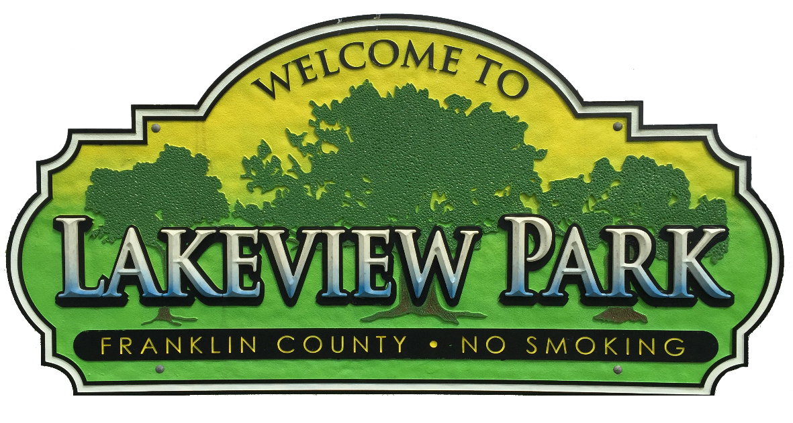

The Franklin County Fiscal Court is soliciting proposals from qualified firms with experience in parks and recreation planning, design, demographics, tourism, asset management and funding strategies for the update of the Franklin County Lakeview Park Feasibility Study/Master Plan.

PROPERTY IDENTIFICATION

Lakeview Park (38°12'49.41"N, 84°49'9.89"W) consists of approximately 111-acres located in the eastern portion of the county at the intersection of Georgetown Road (U.S. Hwy 460) and Steadmantown Lane (KY 2822). Franklin County Fiscal Court purchased the property from William & Betty Jane Arnsparger, Thomas & Mary Lou Schneider and David & Susan Wood in July 1991. The deed of record is located in Deed Book 374, Page 322 in the office of the Franklin County Clerk. While the community is fortunate to have numerous and varied park facilities, Lakeview park is solely owned, operated and maintained by the County government.

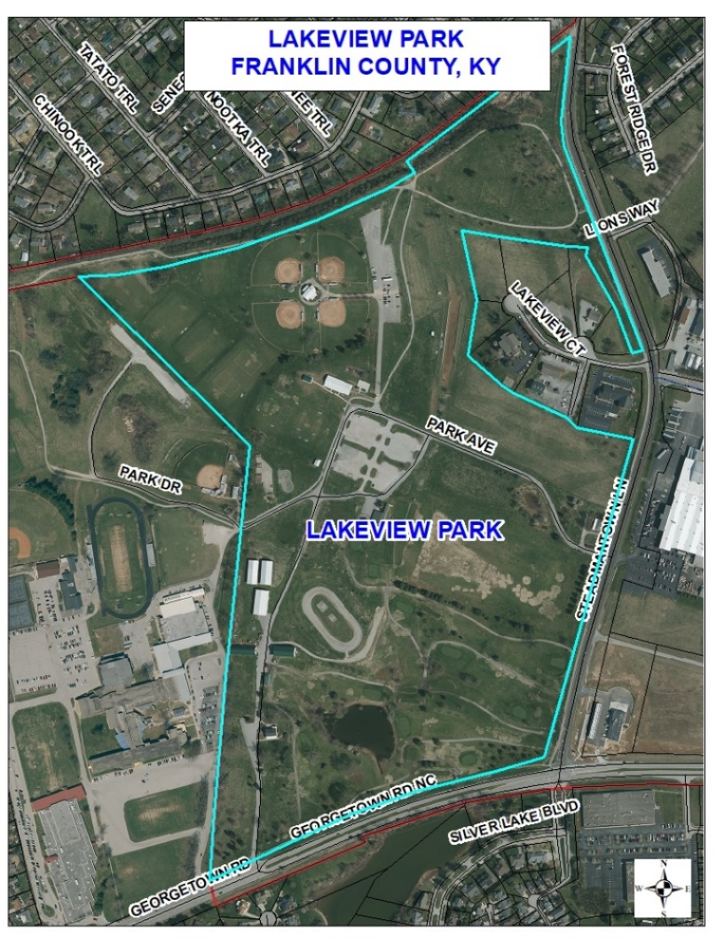
COMMUNITY AT A GLANCE

Franklin County is located in the heart of the Bluegrass region of central Kentucky along Interstate 64. Two primary interstate interchanges along I-64 serve the community; US 127 to the west and US 60 to the east. In addition to being the home of the State Capital, Franklin County is located within the “Golden Triangle” of Louisville, Lexington and Cincinnati. The County geographic area is roughly 211 square miles with an estimated population of 50,000. State government is a large employment base in the community and hosts an estimated 14,500 employees commuting daily. Buffalo Trace and Jim Beam distilleries are long standing historic industries in the region and Buffalo Trace has become a premiere tourist destination. Kentucky State University is a public historically black land-grant university located on Main Street in Frankfort and was established in 1886. The average semester enrollment is approximately 2,000 students.

The Kentucky River runs through the heart of the community and provides a local water-based recreation destination. Elkhorn Creek, located not far from Lakeview Park, is a destination for kayakers of all skill levels. Several campgrounds are located throughout Franklin County for those who enjoy the outdoor experience.

OVERVIEW

The Fiscal Court has a Park Committee consisting of the Judge/Executive and two County Magistrates that meet regularly with the Park Director and other administrative staff to discuss upcoming events, improvements and opportunities for increased public use of the property. In 2017 the Park Committee adopted the first Lakeview Park Master Plan. The plan was prepared by County staff and serves as a basis for decisions by the Park Committee relating to park management and improvement.

FEATURES AND AMENITIES

Lakeview Park is the home of the annual Franklin County Fair and Horse Show which is managed by the Franklin County Fair Board. The week-long event, generally held in mid-July, offers a traditional midway and carnival rides, horse show, beauty pageant, dirt track events and much more.

Considerable effort has been expended to maintain the existing park facilities as well as add new amenities throughout the property. The park hosts a 9-hole golf course, golf driving range, 18-hole disc golf course, softball complex, motorsports area, two volleyball courts, splash pad, playground, numerous soccer fields and two pavilions.

A signature feature of the park is the Carter House. The two-story residential structure was built by Melvin Carter in 1941-42. The brick and structural lumber to construct the home was salvaged from the old Frankfort Penitentiary in downtown Frankfort, formerly located at the intersection of High and Mero Streets. For the past 25-years, the Fiscal Court has utilized the former residence as a gathering place for the community. It is available for rentals on a daily basis and is often used for birthday parties, family reunions, business meetings and as a wedding ceremony and reception venue. The structure underwent a major renovation in 2017 that included new flooring, updated bathrooms, paint, windows and roof. The kitchen was update in 2014. Additionally, both the gazebo and detached garage received a new roof.

SCOPE

Public Engagement and Presentation

The firm will be responsible for ensuring that the general public, stakeholders and elected officials have a variety of means for engagement and input in developing the plan. Strategies for participation should include social media, virtual meetings, press releases, public events and web site. This phase should be an all-inclusive process to determine the needs and values of the community, ideally producing a guiding vision and themes for the plan.

Community Assessment and Need

This phase will analyze existing public and private recreational activities within both the City and County. Previous plans and studies should be utilized by the firm to familiarize themselves with community desires. Based on the analysis, the firm will identify the unserved or underserved opportunities that may be possible at Lakeview Park. Duplicate amenities or recreation activities will only be considered if it is shown that a need exists.

Design and Recommendation of Park Facility Improvements

The 2017 Lakeview Park Master Plan was created to assist with a logical and orderly guide for park improvements. While many improvements within the plan have been completed, the Implementation Table identifies future improvements recommended by the Park Committee. The firm should consider those recommendations along with their own design concept. The final document prepared by the firm shall include an overall park design as well as recommended improvements. Franklin County is interested in exploring the possibility of additional improvements such as an indoor recreation facility, expanded/improved softball complex, indoor or outdoor swimming pool, amphitheater, hotel/meeting space and performing arts space. An implementation table with timeline should accompany the recommendations. The firm shall make every attempt to prepare the design image files to be compatible with ArcMap software. All mapping and image files currently used in the 2017 plan will be made available to the firm.

Funding and Fiscal Analysis

The firm must help identify a wide range of funding sources including grants, improved efficiency of operations, alternative revenue sources, low interest loans, etc. The firm should include the estimated economic impact.

Implementation Strategy

An implementation table shall be provided that identifies each recommended improvement, its priority ranking, timeline, estimated cost and agency responsible. A means to measure progress of the implementation and recommended benchmarks shall be included. Proposals should address each of the above components and describe their approach and the strategy for execution, including applicable examples from previous projects.

Other services as may assigned by the Fiscal Court

SCHEDULE

The schedule is as follows:
- RFP issue – January 19, 2021
- RFP questions due (via email to Robert Hewitt) – February 2, 2021
- RFP due –February 10, 2021
- RFP review completion – end of February 2021
- Invitation to selected consultants to participate in interviews – early March 2021
- In-person interviews with finalists – March 2021
- Project award – April 1, 2021
- First draft report due – June 4, 2021
- Final deliverables & Study due – June 30, 2021

SUBMITTAL

The proposals are not to exceed 50 pages and shall be submitted both electronically to the Franklin County Fiscal Court at HTTPS://TINYURL.COM/FCFCRFP as well as five (5) hard copies no later than 2:00 p.m. local time on February 10, 2021. At 2:05 p.m. local time on February 10, 2021, the proposals will be publicly opened and the name of each firm read aloud. This public opening of the proposals will be live streamed on the Franklin County KY Facebook page at Facebook.com/fcfcky. All submittals shall be clearly marked “Lakeview Park Feasibility Study/Master Plan proposal”. Proposals received after the specified date and time will not be considered.

Proposal Format

Proposals are not to exceed 50 pages and shall include the following:
- Letter of Transmittal
- Description of Project Team
- Description of firm’s capabilities and experience in the preparation of Master Plans
- Description of experience in and proposed strategy for public involvement and outreach
- Proposed general project approach and timeline
- Office location of firm’s key personnel
- Description of firm’s ability to be responsive
PROPOSAL EVAULATION

- Description of the firm’s capabilities and experience in the field of comparable community facilities parks and recreation facilities (40 points)
- Ability of professional personnel (15)
- Past record and experience in the preparation of Feasibility Studies and Master Plans (30 points)
- Performance data on file (10)
- Willingness to meet time and budget requirements (20)
- Firm’s location (5 points)
- Workload (20)
- Demonstration of public engagement experience that is inclusive, effective, productive, and innovative (30 points).

Firms responding to the request will be ranked according to the written information submitted and interviews may be conducted. The Franklin County Fiscal Court will enter negotiations with the highest ranked qualifying firm to execute an agreement. If the parties are unable to negotiate a satisfactory agreement, the second ranked firm will be promptly notified.

Questions regarding this Request for Proposals shall be submitted via email to Robert Hewitt, Planning and Building Codes Director at robert.hewitt@franklincounty.ky.gov

